Eliminate Dead Code

AIM:
To write a C program to implement Dead Code Elimination in Three Address Code (TAC) by identifying and removing statements whose results are not required for the final output.
ALGORITHM:
- Start the program.
- Declare arrays to store Three Address Code statements, left-hand-side variables, right-hand-side expressions, and live status.
- Read TAC statements from the user until END is entered.
- Separate each statement into its left-hand-side variable and right-hand-side expression.
- Traverse the statements in reverse order.
- Mark statements that affect the final outputs x and y as live.
- Check whether a variable's value is used by any live statement.
- Mark the statements defining required variables as live.
- Eliminate statements that are not marked as live.
- Display the optimized Three Address Code.
- Stop the program.

PSEUDO CODE:
BEGIN

DECLARE code, lhs, rhs, live
SET n = 0

DISPLAY "Enter Three Address Code statements"
DISPLAY "Enter END to finish"

WHILE input is available AND n < MAX

READ line

IF line = "END" THEN
EXIT LOOP
END IF

IF line is empty THEN
CONTINUE
END IF

STORE line in code[n]

IF line contains '=' THEN
SPLIT line into lhs[n] and rhs[n]
ELSE
SET lhs[n] = empty
SET rhs[n] = empty
END IF

INCREMENT n

END WHILE

SET all live entries to 0

FOR i = n - 1 DOWNTO 0

IF lhs[i] is empty THEN
SET live[i] = 1
CONTINUE
END IF

IF lhs[i] = "x" OR lhs[i] = "y" THEN
SET live[i] = 1
END IF

FOR j = i + 1 TO n - 1

IF live[j] = 1 AND lhs[i] = lhs[j] THEN
SET live[i] = 1
BREAK
END IF

END FOR

IF live[i] = 1 THEN

IDENTIFY variables used in rhs[i]

FOR each variable var in rhs[i]

SEARCH backward for its previous definition

IF a matching definition is found THEN
MARK that definition as live
END IF

END FOR

END IF

END FOR

DISPLAY "Optimized Three Address Code"

FOR i = 0 TO n - 1

IF live[i] = 1 THEN
DISPLAY code[i]
END IF

END FOR

END

CODE:
#include <stdio.h>
#include <string.h>
#include <ctype.h>

#define MAX 100
#define LEN 100

int main()
{
char code[MAX][LEN];
char lhs[MAX][LEN];
char rhs[MAX][LEN];
int live[MAX] = {0};
int n = 0, i, j;
char line[LEN];

printf("Enter Three Address Code statements.\n");
printf("Enter END to finish:\n");

while (n < MAX && fgets(line, sizeof(line), stdin))
{
line[strcspn(line, "\n")] = '\0';

if (strcmp(line, "END") == 0)
break;

if (strlen(line) == 0)
continue;

strcpy(code[n], line);

char *equal = strchr(line, '=');

if (equal != NULL)
{
*equal = '\0';

sscanf(line, "%99s", lhs[n]);
strcpy(rhs[n], equal + 1);
}
else
{
lhs[n][0] = '\0';
rhs[n][0] = '\0';
}

n++;
}

/* Mark statements needed for final output */
for (i = n - 1; i >= 0; i--)
{
if (lhs[i][0] == '\0')
{
live[i] = 1;
continue;
}

int needed = 0;

for (j = i + 1; j < n; j++)
{
if (live[j] && strcmp(lhs[i], lhs[j]) == 0)
{
needed = 1;
break;
}
}

/* Preserve statements that affect x or y */
if (strcmp(lhs[i], "x") == 0 ||
strcmp(lhs[i], "y") == 0)
{
live[i] = 1;
}

if (needed)
live[i] = 1;

/* Mark definitions of variables used */
if (live[i])
{
char *p = rhs[i];

while (*p)
{
if (isalpha((unsigned char)*p) || *p == '_')
{
char var[LEN];
int k = 0;

while (isalnum((unsigned char)*p) ||
*p == '_')
{
var[k++] = *p++;
}

var[k] = '\0';

for (j = i - 1; j >= 0; j--)
{
if (strcmp(lhs[j], var) == 0)
{
live[j] = 1;
break;
}
}
}
else
{
p++;
}
}
}
}

printf("\nOptimized Three Address Code:\n");

for (i = 0; i < n; i++)
{
if (live[i])
printf("%s\n", code[i]);
}

return 0;
}

INPUT:
t1 = a + b
t2 = c * d
t3 = t1 + 10
x = t3
y = 20
END

OUTPUT:
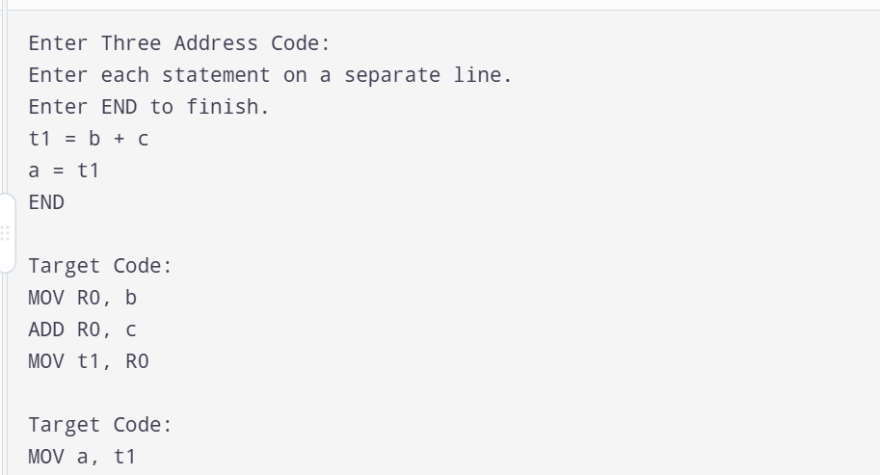

RESULT:
Thus, the C program for dead code elimination in Three Address Code was successfully implemented. It identifies and removes unnecessary statements while retaining statements required for the final outputs x and y, thereby producing optimized Three Address Code.

